**1. INTRODUCTION**

Today India is the most important under developed country in the world. India is the largest country in the use of various types of vehicles. As the available resources to run these vehicles like quality of roads, and unavailability of new technologies in vehicles are causes for accidents. The number of peoples which are dead during the vehicle accidents is also very large as compared to the other causes of death. Though there are different causes for these accidents but proper technology of braking system and technology to reduce the damage during accident are mainly effects on the accident rates. So today implementation of proper braking system to prevent the accidents and to reduce the damage is must for vehicles. To achieve this system modification goal, we design this Automatic Braking system. It is the project which has been fully equipped and designed for auto vehicles.

The number of automobile users is increasing day by day. At the same time, traffic congestion has become a worldwide problem. This problem is mainly due to human driving which involves reaction time delays and judgment errors that may affect traffic flow and cause accidents. Engineers in the automotive industry put a lot of effort in devising systems which ensure safety in road vehicles. Even with all the advancements in vehicle safety technology, the number of people killed in auto accidents continues to rise. Close to 1.2 million people die each year on the world's roads and that number is expected to rise by 65 percent by the year 2020, says a report by World Health Organization (WHO) and the World Bank.

Braking system is the most important system in a car. Generally, a car brake system is operated manually as the driver pushes the brake pedal. If the brake fails, the result can be disastrous. Countless rear-ending automobile accidents could have been prevented or at least reduced in damage cost if the rear-ending driver had applied a sufficient amount of brake pressure at the right time. Unfortunately, the time required by the driver to understand potential accident situations, compounded with driver’s delayed reaction times in applying the brakes, usually causes a lag between the identification of a potential accident situation and the execution of the corrective actions that will prevent the accident. Hence, in such emergency situations an efficient control mechanism has to be employed to avoid accidents.

Therefore, by automating the task of assessing the situation and deciding the correct amount of brake pressure, we could prevent numerous accidents. By that means, the car brake itself should have a good software system to assist a driver along the road. This would significantly decrease the amount of property and monetary loss due to accident damage, and it could save lives.

The aim is to design and develop a control system based on intelligent electronically controlled automotive brake activation system is called “ECU Braking system”. The project consists of IR transmitter and Receiver circuit, Control Unit, Pneumatic bumper system. The IR sensor check the road ahead. If obstacle is detected in the middle brake will be applied.

Over the years, automotive safety has gained an increasing amount of interest from the general public, governments, and the car industry. Traffic accident statistics more than justify this focus, as each year around 1.2 million people dies due to road traffic accidents.

An automobile has been used to move human beings or something since the automobile was invented and the automobile technology has been developed within the last few years. Recently, the automobile is thought as daily necessaries because we spend much time in an automobile and enjoyed the entertainment such as game, e-mail, DVD, mp3, and internet etc. in the car. Car makers in Europe and Japan are developing for safety such as both collision safety and preventive safety and new car technology for intelligent car such as intelligent transport system (ITS), rear view camera system, Road-to-vehicle and Inter-vehicle Communication Systems, auto-parking system, hybrid car, electric car, and hydrogen fuel car. Car makers are beginning to develop equipment for high-end vehicles with systems to sense roadway conditions using cameras, radar, sensors and such in an effort to avoid accidents. The traffic accident is increasing as automobile production has been increasing. It is important to prevent accidents and to protect the driver and pedestrian when accidents were occurred. Therefore, pre-crashing system will be demanded. The pre-crash system is to prevent front-end, rear-end, right-turn and left-turn accidents on roads with poor visibility by using sensor network to find invisible vehicles, which are to be detected by autonomous on-vehicle sensors. The pre-crashing system is processing the sensor data and controlling the vehicle to prevent front-end, rear-end accidents and accidents caused by careless driving. The development of such systems to automatically control vehicles and avoid accidents will accelerate in the future.

The important thing in auto-braking system is detect the distance and speed of front vehicle to prevent a traffic accident.

In conventional vehicles there are different mechanism operated for braking system like hydraulic, pneumatic, air, mechanical, etc. But all these braking mechanisms receive the signal or input power directly from the driver so it totally manual operated. When the driver saw the obstacle or any vehicle in front of his driving vehicle, he was irritated or becomes mazy. Due to this the driver fails to give the proper input to braking system and proper working is not occurs. Also the driver may not able to pay the full attention during night travelling so there are many chances to accidents. After the accident occurs, there is no any provision to minimize the damages of vehicles.

Vehicular automation involves the use of mechatronics, artificial intelligence, and multi-agent system to assist a vehicle's operator. These features and the vehicles employing them may be labeled as *intelligent* or *smart*. A vehicle using automation for difficult tasks, especially navigation, may be referred to as *semi-autonomous*. A vehicle relying solely on automation is consequently referred to as robotic or autonomous. After the invention of the integrated circuit, the sophistication of automation technology increased. Manufacturers and researchers subsequently added a variety of automated functions to automobiles and other vehicles. The final phase of the new modern vehicle shall include:

* Development of improved ABS control systems
* Development and assessment of an electro-hydraulic- BBW (EH-BBW) system
* Individual wheel braking combined with traction control
* Assessing sensor failure and fault tolerant control system design
* Preliminary studies into an electrically actuated system

Re-engineering using simplified models

**2. LITERATURE REVIEW**

**2.1.Design of Accident Prevention System Using QRD 1114 and CNY70 Sensors  
Name of authors:Apeksha S. Chavan1, Dipali D. Pansare2, Swapnil P. Kadam3, Naval K. Mayekar4, Kavita V.Jha5,  
Poonam R. Bhagwat6**

Sleep related accidents tend to be more severe, possibly because of the higher speeds involved and because the driver is unable to take any avoiding action, or even brake prior to the collision. Horne describes typical sleep related accidents as ones where the driver runs off the road or collides with another vehicle or an object, without any sign of hard braking before the impact. Accidents are also caused when street lights are out specially on highways, long distance routes. Here, usually the upper dipper lights are in upper mode. So, when the driver fails to change the mode of the light and at the same time when the car comes from the opposite side.it causes the opposite driver to miss the judgement and gives rise to accident. Accidents are also caused due to the intruders coming suddenly in either side of the vehicle i.e. front, left or right. Due to which the driver misses the judgement and meets with an accident.

**2.1.1.Prevention of Accident Due To Drowsy By  
UsingEye Blink B.Praveen kumar, K.Mahendrakan**

Accident due to drowsy is prevented and controlled when the vehicle is out of control. And also the drunken drive also prevented by installing alcohol detector in the vehicle. The term used here for the reorganisation that the driver is drowsy is by using eye blink of the driver. In recent times drowsiness is one of the major causes for highway accidents. These types of accidents occurred due to drowsy and driver cant able to control the vehicle, when he/she wakes. The drowsiness is identified by the eye blink closure and blinking frequency through infrared sensor worn by driver by means of spectacles frame. The alcohol consumptionisalsoverifiedduringthestartingprocess of the vehicle using alcohol detector. If the driver is drunk then the buzzer indicates and the vehicle doesn’t allow the driver to start the vehicle. If the driver is drowsy, then the system will give buzzersignalandthespeedofthe vehicle is reduced and the obstacle sensor will senses theadjacentvehicletoavoidcollisionwiththat,andifthere is no vehicle in left adjacent side then the vehicle move to the left end of the road byautosteering and controlling and vehicle will be parked with prior indications.

**2.1.2. Research paper: AUTOMATIC BRAKING WITH PNEUMATIC BUMPER SYSTEM**

**Name of authors: Srinivasa Chari.V1, Dr.venkatesh P.R2, Dr.PrasannaRao N.S3, Adil Ahmed S 4**

The technology of pneumatics plays a major role in the field of automation and modern machine shops and space robots.. The aim is to design and develop a control system based intelligent electronically controlled automotive bumper activation and automatic braking system is called AUTOMATIC PNEUMATIC BUMPER AND BREAK ACTUATION BEFORE COLLISION. This project consists of IR transmitter and Receiver circuit, Control Unit, Pneumatic bumper system and pneumatic braking system. The IR sensor senses the obstacle. There is any obstacle closer to the vehicle (with in 3-4 feet), the control signal is given to the bumper activation system and also pneumatic braking system simultaneously. The pneumatic bumper and braking system is used to product the man and vehicle. This bumper and braking activation system is only activated the vehicle speed above 30-40 km per hour. This vehicle speed is sensed by the proximity sensor and this signal is given to the control unit and pneumatic bumper and braking activation system.

It is the project which has been fully equipped and designed for auto vehicles. The technology of pneumatics plays a major role in the field of automation and modern machine shops and space robots. The aim is to design and develop a control system based on intelligent electronically controlled automotive bumper activation system is called “automatic pneumatic bumper and break actuation before collision”. The project consists of IR transmitter and Receiver circuit, Control Unit, Pneumatic bumper system. The IR sensor senses the obstacle. There is any obstacle closer to the vehicle (within 1feet), the control signal is given to the bumper and break activation system. This bumper activation system is activated when the vehicle speed above 40-50 km per hour. The speed is sensed by the proximity sensor and this signal is transfer to the control unit and pneumatic bumper activation system.

**2.1.3 Automatic safety system for automobiles**

**Dr. P. Poongodi PPG Institute of Technology, Coimbatore, Tamil Nadu, INDIA – 641012.**

**Mr. P. Dineshkumar, Karpagam University, Coimbatore, Tamil Nadu, INDIA – 641021.**

In this paper, the need for safety of vehicles by reducing the impact of crash by applying a smooth or partial braking with the help PIC 16F877a micro controller is proposed. The driver’s risk of measuring a certain object from a particular distance and failing to notice within the critical limit such conditions are met while designing this work. Once a similar situation is faced the acceleration of the automobile will be directly controlled without disturbing the safe throttle (actual throttle mechanism) of the automobile, the designed machine itself takes the control of acceleration pedal if the brake is not applied within the critical distance. The method is proposed in such a way to be applied to both low cost and existing vehicles as these were already build for the Indian roads.

The deceleration is said to be negative acceleration. You are driving your car and the traffic light ahead turns red. You apply the brakes for 3.59 s, and the velocity of the car decreases to +4.99 m/s.If the car's deceleration has a magnitude of 2.53 m/s2. Average passenger car deceleration rate from coasting on level terrain with Auto Tran., from 60-70 mph speed range.

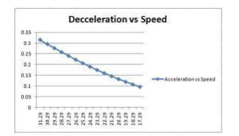

Fig no.2.1.3.1

The microcontroller used is the PIC 16F877A, which provides a safe and reliable method for controlling. The system needs to be attached to the existing method in which cars are designed so flexibility is a major need. The method is shown in Figure

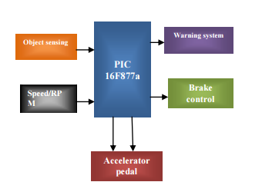

Fig no.2.1.3.2

In the Figure , the object sensed using any of the object sensor is given as input along with speed obtained from the RPM counter which will be sent to the controller based on the commands provided it will calculate the speed that’s need to be controlled based on the PID algorithm

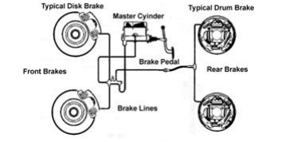

Fig no.2.1.3.3

The above Figure is the proposed braking method the controlling of the rear brake will adjust the torque of the wheel enabling the system to control the application of brakes. The speed control will be only applied if the distance is below 45% to collide or else the driver will only have control after he applies the brake. The system will take over if it is too close this will make the brakes and accelerator pedals to be cut from the drivers control and the system will apply the brake and here the algorithm provides a smooth operation of the vehicle and sudden jerks will not be realized.

The method was simulated, the results were verified through MATLAB 2009R and the graphs are plotted. Safety and automation is the main trend of future vehicle development. In the future authors believe that safety and warning measurement will be the basic all existing vehicles. The warning and smooth braking system will not only prevent accidents but ensures comfortable travelling at the highways also. When the driver cannot operate the car effectively or vehicle unrestrained or driver doze off, it can help the vehicle slowing down on braking

**2.1.4 Fabrication of auto-braking system for pre-crash safety using sensor.**

**International Journal of Control and Automation Vol. 2, No. 1, March, 2009**

**Name of authors–EungSoo Kim**

The Auto-Braking System was designed by VHDL and fabricated to keep a distance between two cars. It provides PreCrash Safety System for Intelligent Car. This module can detect the distance between front vehicle and driver’s vehicle to keep a constant distance using a sensor and operate the brake system forcibly if the driver does not decrease the speed of car. The system displays the distance between the two vehicles and the speed of your vehicle. The performance of the system was good.

The fabricated auto-braking system has the sensor part and signal processing part to prevent an accident as shown in Figure 1. It performed monitoring the environment and sensor signal processing. The sensor embedded in vehicle will detect the road environment, such as self-velocity, distance from front vehicle, and surroundings vehicles, using infrared sensor and ultrasonic sensor. These sensors were operated all the time during driving. The processing part accepted the signal from sensors and processed the signals and generated the instructions and transferred the generated instruction to control unit of transmission and brake of vehicle. There are three cases occurred in real situations. One case is that the distance between the front car and driver’s car is far enough to defend crashing and self-velocity is the same velocity of front car or slower than that of front car. In this case, the driver’s car is continuously running without changing its velocity. Another case is that the distance between the front car and driver’s car is near and self-velocity is slower than that of front car. In this case, the driver’s car is also continuously running without changing its velocity. Another case is that the distance between the front car and driver’s car is near and self-velocity is faster than that of front car. In this case, the driver’s car is continuously running only when the driver reduce speed. But if the driver does not reduce speed, the auto-braking system may forcibly reduce the speed of driver’s car to protect an accident. The reason is that if the driver does not reduce speed, the accident will be occurred and the driver will be hurt.

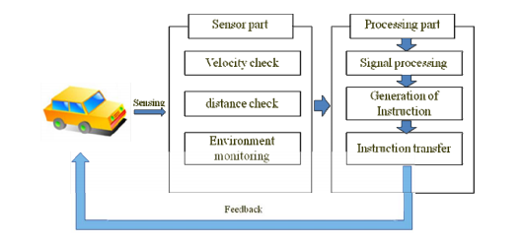

Fig no.2.1.4.1

The auto-braking system was deigned by VHDL and fabricated using FPGA to prevent accident. The system was mounted on a miniature car and tested. When the distance was getting closer, the auto-braking system was working and the speed will slow down if a driver does not reduce the speed of automobile. We also fabricated the auto-braking system using Labview. We will replace an ultrasonic sensor with a radar sensor as the auto-braking system is mounted on a real automobile.

**2.1.5 A deceleration control method of automobile for collision avoidance based on driver perceptual risk**

**IEEE international Conference on Intelligent Robots and Systems, Oct 4881-4886**

**Name of authors-Takahiro Wada**

To reduce rear-end crash of automobiles, it is important to judge necessity of deceleration assistance as earlier as possible and initiate the assistance naturally. On the other hand, we have derived a mathematical model of driver's perceptual risk of proximity in car following situation and successfully derived driver deceleration model to describe deceleration patterns and brake initiation timing of expert driver. In this research, an automatic braking system for collision avoidance will be proposed based on the formulated brake profile model and brake initiation model of expert driver to realize smooth, secure brake assistance naturally. It will be shown that the proposed control method can generate smooth profile for various conditions. In addition, experimental results using a driving simulator will show validity of the proposed system based on subjective evaluation

**2.1.6 A theory of visual control of braking based on information about time to collision, Perception, Vol 5, pp 437-459**

**Name of authors -Lee**

Collision Warning Systems (CWS) are safety systems designed to warn the driver about an imminent collision. A CWS monitors the dynamic state of the traffic in real time by processing information from various proprioceptive and exteroceptive sensors. It assesses the potential threat level and decides whether a warning should be issued to the driver through auditory and/or visual signals. Several measures have already been defined for threat assessment and various CWS have been proposed in literature. In this paper, we will focus on two time-based measures that assess both front and rear collision threats. In particular, a new threat metric, the time-to-last-second-acceleration (Tlsa), for lead vehicles in rear-end collision is proposed and compared with its counterpart, the time-to-last-second-braking (Tlsb). The Tlsa is a novel time-based approach that focuses on the lead vehicle (as opposed to the following vehicle). It inherits the properties of the Tlsb and, as such, is coherent with the human judgment of urgency and severity of threats. It directly quantifies the threat level of the current dynamic situation before a required evasive action (i.e. maximum acceleration) needs to be applied. Furthermore, different warning thresholds are proposed by considering the average driver reaction time. Its effect on decreasing the severity of a rear-end collision is studied and its reliability is tested using a well-established physics-based robotics simulator, namely Webots

**3. COLLISION AVOIDANCE**

Automatic braking by the system after sensing an obstacle can be executed in two modes: In collision avoidance, the collision is avoided by the automatic braking, but the driver will not be warned in this type of system. In collision mitigation system, the sensors detect the possibility of collision but will not take immediate action. A warning will be sent to the driver in the form of a signal or a voice message. The decision to apply brakes is left with the driver and the brakes are applied automatically only in the most emergency situations.

A collision avoidance system (CAS) should involve, at least, the following three main parts: 1) object detection; 2) decision making; and 3) actuation [1]. Object detection relates to perception tasks that analyze the environment information obtained by one or more sensors. A decision-making system interprets these estimates and makes a decision on when and how collisions can be avoided. The complexity of this stage depends on the specific traffic situation. Finally, one actuation system adapts the target commands generated by the previous stage and transforms these commands to low-level control signals needed by the respective actuators: 1) throttle; 2) brake; and 3) steering. The generated signals have to take the corresponding actions to avoid the collision.

**4. DRAWBACKS IN THE EXISTING APPROACHES**

• ABS can only help if the rider applies it in the right time manually and maintains the distance calculations. ABS has its own braking distance.

• Moreover many commuter bikes in India don’t have the option of ABS because it’s very expensive.

• laser assisted braking could not work effectively in rainfall and snowfall season and laser is easily affected by atmospheric conditions.

In our project we are using infrared sensors and Microcontroller using which the speed of the vehicle is automatically reduced and voice alarms are given to the user when it approaches an object by automatically sensing the position of the object/vehicle.

**5. PROBLEM STATEMENT**

In conventional vehicles there are different mechanism operated for braking system like hydraulic, pneumatic, air, mechanical, etc. But all these braking mechanisms receive the signal or input power directly from the driver so it totally manual operated. When the driver saw the obstacle or any vehicle in front of his driving vehicle, he gets irritated or becomes mazy. Due to this the driver fails to give the proper input to braking system and proper working does not occur. Also the driver may not able to pay the full attention during night travelling so there are many chances to accidents. After the accident occurs, there is no provision to minimize the damages of vehicles. Currently bumpers used in vehicles are of rigid types. These bumpers have specific capacity and when the range of the accidental force is very high then the bumpers are fails and these force transferred towards the passengers. So this system never reduces the damage of both vehicle and passengers.

To overcome these unwanted effects we have to design the Automatic Braking System with Pneumatic Bumpers.

**6. OBJECTIVES**

The main target for this project is, cars can run automatic braking due to obstacles when the sensor senses the obstacles. The braking circuit function is to brake the car automatically after received signal from the sensor. The primary objective of this paper is to develop a safety car braking system using infrared sensor and to design a vehicle with less human attention to the driving.

Automatic Braking System with Pneumatic Bumpers which has following objectives:

* To increase the sureness of braking Application.
* To increase the response time of braking system.
* To improve the pre-crash safety.
* To avoid the percentage of passenger injury by using external vehicle safety.
* To reduce the requirement of internal safety devices like air bags.

**7. SCOPE**

The project is combination of the mechanical and Electronics, which is fairly known as the Mechatronics. The upcoming world is full of Automation so we need to develop a system which is fully automatic.

Now a day vehicle accidents is the major problem. This breaking system used an innovative project for the purpose of preventing accidents happens in the restricted roadways. To overcome this problem we are going to develop a system which is helpful for the reduction of road accidents. It is the project which has been fully equipped and designed for auto vehicles. The technology of pneumatics plays a major role in the field of automation and modern machine shops and space robots.

**8. METHODOLOGY**

The project mainly consists of the four wheel prototype which driven by using a motor. The frontal area is covered by the bumper, which is connected to the one pneumatic cylinder. The IR sensor is placed on specs. When eye blink count get reduce then the installed infrared sensor senses that count. The received signal by IR sensor is provided to the control unit. This control unit operates the relay according to the input signal.

At the same time, IR sensor activates solenoid which applies the brake as well as the pneumatic bumper. We must have to calculate the braking force for stoppage of vehicle and force acting on bumper in the case of collision. Also we have to calculate the cylinder dimensions for the calculation of the force applied.

**9. PROPOSED SYSTEM**

We have pleasure in introducing our new project “eye sensor braking system”,which is fully equipped by IR sensors circuit,automatic braking and Pneumatic bumper activation circuit when the driver is not applying the brakes manually in case of emergency. It is a genuine project which is fully equipped and designed for Automobile vehicles. This forms an integral part of best quality. This product underwent strenuous test in our Automobile vehicles and it is good.

The important components of our project are,

* IR transmitter
* IR receiver
* Control Unit with Power supply
* Solenoid Valve
* Flow control Valve
* Braking system
* Pneumatic bumper
* Air Tank (Compressor)

The IR TRANSMITTER circuit is to transmit the Infra-Red rays. The IR transmitter is used to transmit the infrared rays. The IR receiver is used to receive  
the reflected infrared rays from the obstacle. If the ray transmitted by sensor are reflected back means there is obstacle in the path .

This reflected Infra-Red rays are received by the receiver circuit which is called as called “**IR RECEIVER”.**

The IR receiver circuit receives the reflected IR rays and giving the control signal to the control circuit. The control circuit is used to activate the solenoid valve.

This system works when driver does not apply brake manually In this case the chances of accident are very high. When any obstacle is detected by IR sensor the signals are send to braking system. Thus the brakes are applied.

This system can help to save the people sitting inside the vehicle and also will save the external body of vehicle from getting damaged.

**10. PROPOSED BLOCK DIAGRAM OF PROJECT**

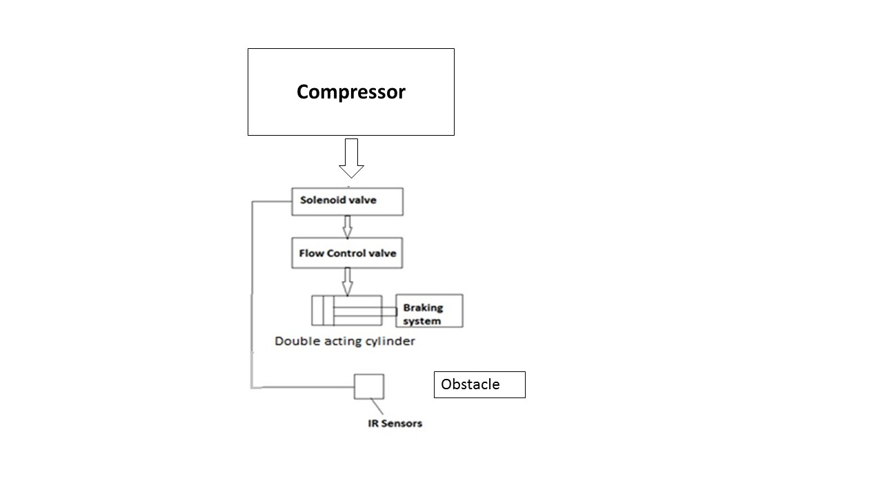

Fig no.10.a

**10. 1 Proposed 3D Model of project**

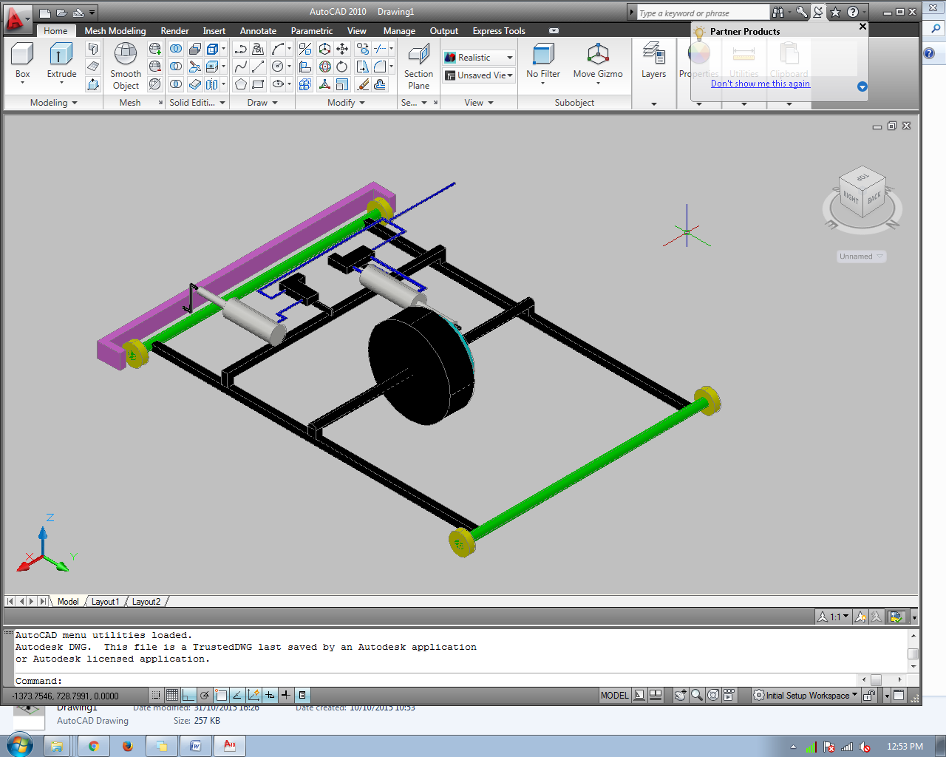

Fig no.10.1.a

**11. CALCULATION**

Frame design

Material used –mild steel ,square pipe

Area=1*1inch=25.4*25.4=645.16mm2

Length of link=20 inch=508 mm

Weight of project=15 kg= 15*9.81 =147.15 N

**11.1.Solution**

**11.1.1 Effective length**

Effective length ,when both end fixed,

Le===254 mm

**11.1.2. Internal Area**

Internal width and depth, which have 3 mm thickness,

d=b=38.1-2*3 =32.1 mm

**11.1.3.Moment of inertia**

I= $\frac{BD^{3}-bd^{3}}{12}$ = $\frac{25.4*{25.4}^{3}-19.4{*19.4}^{3}}{12}$ =22882.048 mm4

**11.1.4. Crippling load by Euler’s formula**

**Pc===**

**=**735.1 kN

**11.1.5. Frame design**

Material used –mild steel ,square pipe

Area=1*1inch=25.4*25.4=645.6mm2

Length of link=30 inch=762 mm

Weight of project=15 kg= 15*9.81 =147.15 N

**11.2 Solution**

**11.2.1. Effective length**

Effective length ,when both end fixed,

Le===381 mm

**11.2.2. Internal Area**

Internal width and depth, which have 3 mm thickness,

d=b=38.1-2*3 =32.1 mm

**11.2.3.Moment of inertia**

I= $\frac{BD^{3}-bd^{3}}{12}$ = $\frac{25.4*{25.4}^{3}-19.4{*19.4}^{3}}{12}$ =22882.048mm4

**11.2.4. Crippling load by Euler’s formula**

**Pc===**

**=**384.945 kN

**12. BRAKE CALCULATION**

Brake drum (Front) = 110 mm

Brake Drum (Rear) = 110 mm

This brake is Internally Expanding brake.

Radius of drum = R = 55 mm

Face Width = b = 30 mm

h = R-(b/2)

= 55- (30/2)

= 40 mm

Length between pivot and spring = L = 90 mm

Assuming  
µ = 0.4

Pmax = 0.3

ɵ1 =0

ɵ2 =90

= 90* (π/180)

= 1.57079 rad

ɵmax = 90

**12.1.For leading shoe:**

MNL = $\frac{Pmax**b*R*h}{4\sin{θmax}}$*{2($θ2-θ1$)-(sin $2θ2-sinθ1$)}

= $\frac{0.3*30*55*40}{4\sin{90}}$*{2(1.57079 $-0$)-(sin $180-sin0$)}

= 4950*(3.14158-0)

=15550.821 N-mm

MFL = $\frac{μ*Pmax*b*R}{4\sin{θmax}}$ { 4R(cos $θ1$- cos $θ2$)-h(cos $2θ1$- cos $2θ2$)}

= $\frac{0.4*.3*30*55}{4\sin{90}}$ {4* 55 (cos $0$- cos 90) – 40 (cos $0$- cos $180$)}

= 49.5*(180*1-70)

= 6930 N-mm

Actuating Force,

F*L = MNL - MFL

F = $\frac{MFL-MNL}{L}$

F = $\frac{15550.821-6930}{90}$

F= 93.7859 N

Braking Torque = $\frac{μ*Pmax*R^{2}*b*(\cos{θ1-\cos{θ2}})}{\sin{θmax}}$

= $\frac{0.4*0.3*{55}^{2}*30*(\cos{0-\cos{90}})}{\sin{90}}$

= 10890 N-mm

=10.89 N-m

**12.2.For Trailing shoe:**

MNT = $\frac{Pmax**b*R*h}{4\sin{θmax}}$*{2($θ2-θ1$)-(sin $2θ2-sinθ1$)}

= $\frac{Pmax*30*55*40}{4\sin{90}}$*{2(1.57079 $-0$)-(sin $180-sin0$)}

= Pmax*16500*(3.15158-0)

=Pmax*51836.07 N-mm

MFT = $\frac{μ*Pmax*b*R}{4\sin{θmax}}$ { 4R(cos $θ1$- cos $θ2$)-h(cos $2θ1$- cos $2θ2$)}

= $\frac{0.4*Pmax*30*55}{4\sin{90}}$ {4* 45 (cos $0$- cos 90) – 35 (cos $0$- cos $180$)}

= Pmax*165*140

= 23100*Pmax N-mm

Actuating Force,

F*L = MNT + MFT

F = $\frac{MFT+MNT}{L}$

95.7869 = $\frac{51836.07*Pmax+23100*Pmax}{90}$

Pmax = 0.115 N/mm2

Braking Torque = $\frac{μ*Pmax*R^{2}*b*(\cos{θ1-\cos{θ2}})}{\sin{θmax}}$

= $\frac{0.4*0.115*{55}^{2}*30*(\cos{0-\cos{90}})}{\sin{90}}$

= 4174 .56 N-mm

=4.1745 N-m

Total Braking torque Capacity,

Tb = TbL + TbT

= 10.89+4.1745

= 15.0645 N-m

**13. DOUBLE ACTING PNEUMATIC CYLINDER**

**13.1. Given data**:

Cylinder : 20*50

Volume of air exhaust =stroke *area of piston

=100*π/4*20^2

=31415.92 m^3

Area of piston =π/4*20^2314.15mm^2

Outstroke force (F) = pressure *Area of cylinder

=0.4*314.15

=125.66 N

Piston rod area A1 = π/4*d^2

= π/4*7^2

=38.48mm^2

Effective area= piston area- piston rod area

=314.15-38.48

=275.66 mm^2

Instroke force= P*A

=0.4*275.66

=110.26 N

.

**14. CHAIN DESIGN**

Chain -06 B

Pitch -9.525mm

Roller diameter,d1=6.35 mm

Width, b1=5.72 mm

Transverse pitch pt=54.85 mm

z1=18

z2=18

Approximate centre distance,

a=40p

=40*9.525

=381mm

No of links,

Ln=2(a/p)+ $\frac{z1+z2}{2}+\left(\frac{z1-z2)}{2π}\right)*(\frac{p}{a})$

=2(381/9.525)+ $\frac{18+18}{2}+0$

=98

**15. DESIGN OF SPROCKET**

Used chain no.06B

For Z=18

From table no 14.1

Pitch ,P=9.525

Width between inner Plates , b1=5.72

Roller diameter, d1=6.35

Transverse pitch pt=10.24

1.pitch circle diameter

D= $\frac{p}{sin⁡(180/z)}$

= $\frac{9.525}{sin⁡(180/18)}$

=54.85 mm

Top diameter (Da)

(Da)max=D+1.25p-d1

=54.85+1.25*9.525-6.35

=60.4 mm

Root diameter ,

Df=D-2r1

But roller seating radius (r1)

(r1)max=0.505d1+0.069 $\sqrt[3]{d1}$

=0.505*6.35+0.069 $\sqrt[3]{6.35}$

=3.33 mm

Df=D-2r1

=54.85-2*3.33

=48.19mm

Tooth flank radius (re)max=0.008d1(Z2+180)

=0.008*6.35 (182+180)

=25.6 mm

(re)min=0.12d1(Z+2)

=0.12*6.35 (18+2)

=15.24

Roller seating angle (ά)max=(120-90/Z)

=(120-90/18)

=115

(ά)min=(140-90/Z)=140-90/18

=135

Tooth height above the pitch polygon

(ha)max=0.625 p-0.5d1+0.8p/Z

=0.625*9.525-0.5*6.35+0.8*9.525/18

=3.2 mm

(ha)min=0.5(p-d1)

=0.5(9.525-6.35)

=1.58 mm

Tooth side radius (rx)=p

Tooth width bf1=0.95b1

=0.95*5.72

=5.434 mm

Tooth side relief (ba) =0.1p

=0.1*9.525

=0.9525 mm

**16. MAIN COMPONENTS OF OUR PROJECT ARE**

1. Double acting pneumatic cylinders
2. 5/2 Solenoid valve
3. Chain sprocket
4. Axles
5. Wheels
6. Bearings

**16.1. Double acting cylinder:**

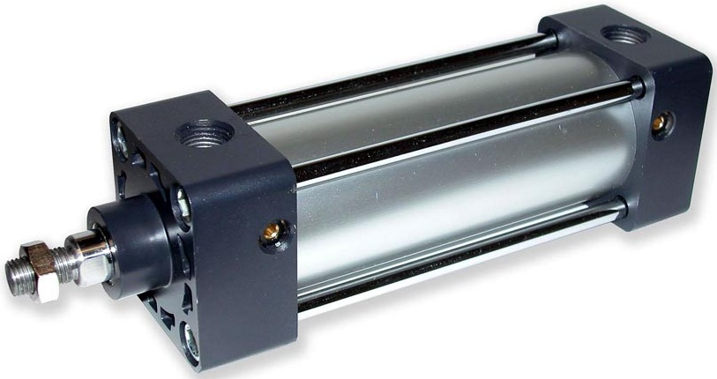Fig.no.16.1

# Pneumatic cylinder (sometimes known as air cylinders) are mechanical devices which use the power of compressed gas to produce a force in a reciprocating linear motion.

# Like hydraulic cylinders, something forces a piston to move in the desired direction. The piston is a disc or cylinder, and the piston rod transfers the force it develops to the object to be moved. Engineers sometimes prefer to use pneumatics because they are quieter, cleaner, and do not require large amounts of space for fluid storage.

# 16.2. Forces in a Double-Acting Cylinder:

We already know that a double-acting cylinder can be much more useful to us in pneumatics because both the outstroke and instroke are controlled by compressed air. This allows us to make use of both the outstroke and the instroke force. What we learn, however, is that the outstroke force is greater than the instroke force. Why is this the case?

During the outstroke, the compressed air pushes against the surface area of the piston in the same way as in the single-acting cylinder.

fig37FFf

However, during the instroke the surface area is reduced because of the piston rod. This means that the compressed air does not have as big an area to push Fig.no.16.2.1.

against and so it does not produce as big a force.

fig38

We can find this surface area, or *effective area* as it is known, by calculating the area of the piston rod and subtracting it from the surface area of the piston.

Effective area = piston area – piston rod area

Fig.no.16.2.2.

**16.3. 5/2 solenoid valve:**

**Directional control valves** are one of the most fundamental parts in hydraulic machinery as well and pneumatic machinery. They allow fluid flow into different paths from one or more sources. They usually consist of a spool inside a cylinder which is mechanically or electrically controlled. The movement of the spool restricts or permits the flow, thus it controls the fluid flow.

A solenoid valve is an electromechanically operated valve. The valve is controlled by an electric current through a solenoid: in the case of a two-port valve the flow is switched on or off; in the case of a three-port valve, the outflow is switched between the two outlet ports. Multiple solenoid valves can be placed together on a manifold.

Solenoid valves are the most frequently used control elements in fluidics. Their tasks are to shut off, release, dose, distribute or mix fluids. They are found in many application areas. Solenoids offer fast and safe switching, high reliability, long service life, good medium compatibility of the materials used, low control power and compact design

Solenoid valves are used in fluid power pneumatic and hydraulic systems, to control cylinders, fluid power motors or larger industrial valves. Automatic irrigation sprinkler systems also use solenoid valves with an automatic controller. Domestic washing machines and dishwashers use solenoid valves to control water entry into the machine. Solenoid valves are used in the paintball industry, solenoid valves are usually referred to simply as "solenoids." They are commonly used to control a larger valve used to control the propellant In addition to this, these valves are now being used in household water purifiers.

Solenoid valves can be used for a wide array of industrial applications, including general on-off control, calibration and test stands, pilot plant control loops, process control systems, and various original equipment manufacturer applications.

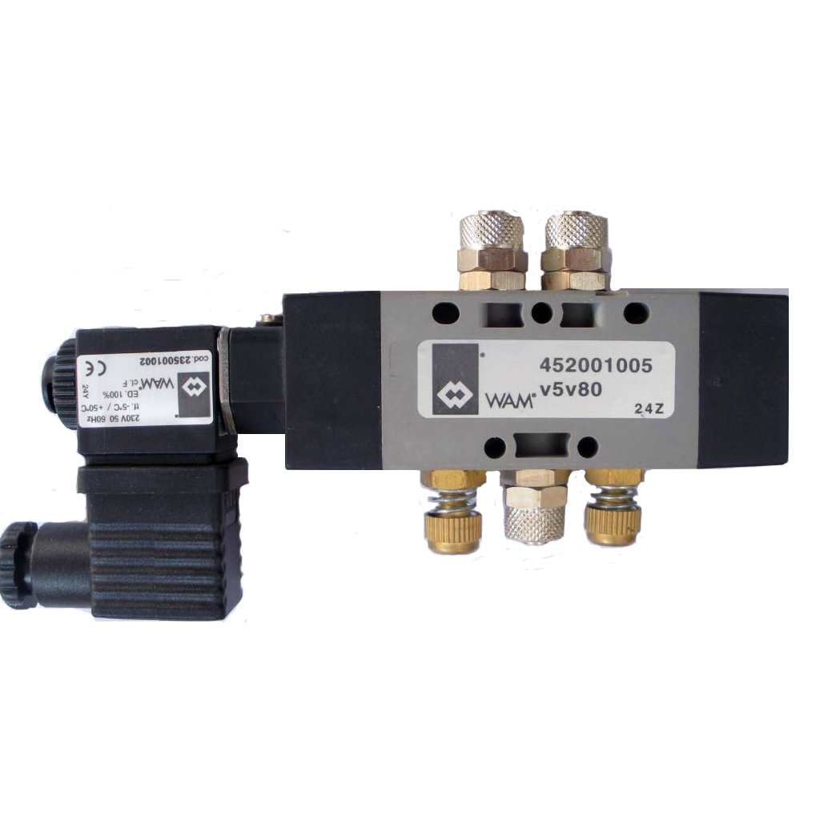

Fig no.16.3.1

**16.4. Chain Sprocket**

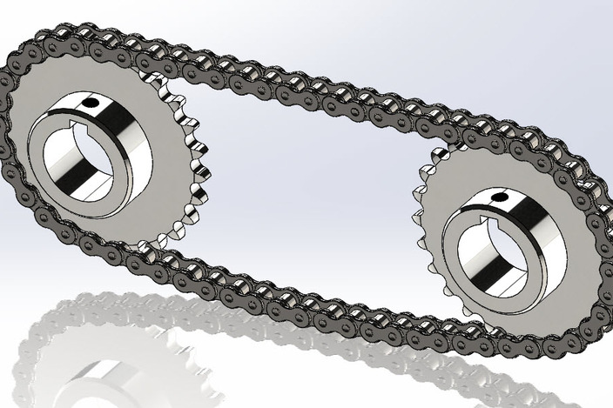

Fig no.16.4.1

A sprocket or sprocket-wheel is a profiled wheel with teeth, cogs, or even sprockets that mesh with a chain, track or other perforated or indented material.The name 'sprocket' applies generally to any wheel upon which radial projections engage a chain passing over it. It is distinguished from a gear in that sprockets are never meshed together directly, and differs from a pulley in that sprockets have teeth and pulleys are smooth.

Sprockets are used in bicycles, motorcycles, cars, tracked vehicles, and other machinery either to transmit rotary motion between two shafts where gears are unsuitable or to impart linear motion to a track, tape etc. Perhaps the most common form of sprocket may be found in the bicycle, in which the pedal shaft carries a large sprocket-wheel, which drives a chain, which, in turn, drives a small sprocket on the axle of the rear wheel . Early automobiles were also largely driven by sprocket and chain mechanism, a practice largely copied from bicycles.

Sprockets are of various designs, a maximum of efficiency being claimed for each by its originator. Sprockets typically do not have a flange. Some sprockets used with timing belts have flanges to keep the timing belt centered. Sprockets and chains are also used for power transmission from one shaft to another where slippage is not admissible, sprocket chains being used instead of belts or ropes and sprocket-wheels instead of pulleys. They can be run at high speed and some forms of chain are so constructed as to be noiseless even at high speed.

**16.5. Bearing:**

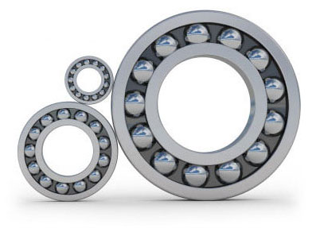

Fig.no.16.5.1

A bearing is a machine element that constrains relative motion to only the desired motion, and reduces friction between moving parts. The design of the bearing may, for example, provide for free linear movement of the moving part or for free rotation around a fixed axis; or, it may prevent a motion by controlling the vectors of normal forces that bear on the moving parts. Many bearings also facilitate the desired motion as much as possible, such as by minimizing friction. Bearings are classified broadly according to the type of operation, the motions allowed, or to the directions of the loads (forces) applied to the parts.

The term "bearing" is derived from the verb "to bear"; a bearing being a machine element that allows one part to bear (i.e., to support) another. The simplest bearings are bearing surfaces, cut or formed into a part, with varying degrees of control over the form, size, roughness and location of the surface. Other bearings are separate devices installed into a machine or machine part. The most sophisticated bearings for the most demanding applications are very precise devices; their manufacture requires some of the highest standards of current technology.

**16.6. Infrared Sensor**

There is a wide range of sensor technologies available for vehicle detectors. There are two types of infrared (IR) detectors, active and passive. Active infrared sensors operate by transmitting energy from either a light emitting diode (LED) or a laser diode. An LED is used for a non-imaging active IR detector, and a laser diode is used for an imaging active IR detector. In both types of detectors the LED or laser diode illuminates the target, and the reflected energy is focused onto a detector consisting of a pixel or an array of pixels. The measured data is then processed using various signal-processing algorithms to extract the desired information. Active IR detectors provide count, presence, speed, and occupancy data in both night and day operation. The laser diode type can also be used for vehicle classification because it provides vehicle profile and shape data. A passive infrared system detects energy emitted by objects in the field of view and may use signal-processing algorithms to extract the desired information. It does not emit any energy of its own for the purposes of detection. Passive infrared systems can detect presence, occupancy, and count. Some of the advantages of infrared detectors are that they can be operated during both day and night, and they can be mounted in both side and overhead configurations. Disadvantages are that infrared detectors can be sensitive to inclement weather conditions and ambient light. The choice of detector materials and construction of the system, as well as sophisticated signal processing algorithms, can compensate for the disadvantages

The working of any Infrared sensor is governed by three laws: Planck’s Radiation law, Stephen – Boltzmann law and Wien’s Displacement law. Planck’s law states that “every object emits radiation at a temperature not equal to 00K”. Stephen – Boltzmann law states that “at all wavelengths, the total energy emitted by a black body is proportional to the fourth power of the absolute temperature”. According to Wien’s Displacement law, “the radiation curve of a black body for different temperatures will reach its peak at a wavelength inversely proportional to the temperature”.

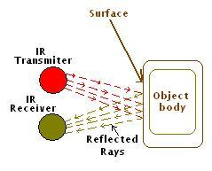

Fig.no.16.6.1

The basic concept of an Infrared Sensor which is used as Obstacle detector is to transmit an infrared signal, this infrared signal bounces from the surface of an object and the signal is received at the infrared receiver.

**17. PROCESS SHEET**

Following operations were performed to fabricate the Base frame: -

**17.1 Cutting**

The material as our required size. The machine used for this operation is power chop saw. A power chop saw, also known as a drop saw, is a power tool used to make a quick, accurate crosscut in a workpiece at a selected angle. Common uses include framing operations and the cutting of molding. Most chop saws are relatively small and portable, with common blade sizes ranging from eight to twelve inches. The chop saw makes cuts by pulling a spinning circular saw blade down onto a workpiece in a short, controlled motion. The workpiece is typically held against a fence, which provides a precise cutting angle between the plane of the blade and the plane of the longest workpiece edge. In standard position, this angle is fixed at 90°. A primary distinguishing feature of the miter saw is the miter index that allows the angle of the blade to be changed relative to the fence. While most miter saws enable precise one-degree incremental changes to the miter index, many also provide "stops" that allow the miter index to be quickly set to common angles (such as 15°, 22.5°, 30°, and 45°). The time required for this operation is 50 minutes.

**17.2 Finishing**

The edges with grinder using grinding wheel. The machine used for this operation is hand grinder. An angle grinder, also known as a side grinder or disc grinder, is a handheld power tool used for cutting, grinding and polishing. Angle grinders can be powered by an electric motor, petrol engine or compressed air. The motor drives a geared head at a right-angle on which is mounted an abrasive disc or a thinner cut-off disc, either of which can be replaced when worn. Angle grinders typically have an adjustable guard and a side-handle for two-handed operation. Certain angle grinders, depending on their speed range, can be use*d* as sanders, employing a sanding disc with a backing pad or disc. The backing system is typically made of hard plastic, phenolic resin, or medium-hard rubber depending on the amount of flexibility desired. The time required for this operation is 20 minutes.

**17.3. Welding**

Square pipes of different lengths to make frame. The machine used for this operation is electric arc welding. Electrical arc welding is the procedure used to join two metal parts, taking advantage of the heat developed by the electric arc that forms between an electrode (metal filler) and the material to be welded. The welding arc may be powered by an alternating current generator machine (welder). This welding machine is basically a single-phase static transformer Suitable for melting RUTILE (sliding) acid electrodes. Alkaline electrodes may also be melted by alternating current if the secondary open-circuit voltage is greater than 70 V. The welding current is continuously regulated (magnetic dispersion) by turning the hand wheel on the outside of the machine, which makes it possible to select the current value, indicated on a special graded scale, with the utmost precision. To prevent the service capacities from being exceeded, all of our machines are fitted with an automatic overload protection which cuts of the power supply (intermittent use) in the event of an overload. The operator must then wait for a few minutes before returning to work. This welding machine must be used only for the purpose described in this manual. Read the entire contents of this manual before installing, using or servicing the equipment, paying special attention to the chapter on safety precautions. Contact your distributor if you do not fully understand these instructions. The time required for this operation is 150 minutes.

**17.4. Polishing**

The welded joints with hand grinder using grinding wheel. The machine used for this operation is hand grinder. With refinement, grinding becomes polishing, either in preparing metal surfaces for subsequent buffing or in the actual preparation of a surface finish, such as a No. 4 polish in which the grit lines are clearly visible. Generally speaking, those operations which serve mainly to remove metal rapidly are considered as grinding, while those in which the emphasis is centred on attaining smoothness are classified as polishing. Grinding employs the coarser grits as a rule while most polishing operations are conducted with grits of 80 and finer. If polishing is required, start with as fine a grit as possible to reduce finishing steps. There is a wide range of grinding and polishing tools on the market and advice is available from ASSDA members to assist in particular applications. Polishing operations are conducted with the abrasive mounted either on made-up shaped wheels or belts which provide a resilient backing. The base material may be in either a smooth rolled or a previously ground condition. If the former, the starting grit size may be selected in a range of 80 to 100. If the latter, the initial grit should be one of sufficient coarseness to remove or smooth out any residual cutting lines or other surface imperfections left over from grinding. In either case, the treatment with the initial grit should be continued until a good, clean, uniform, blemish-free surface texture is obtained. The initial grit size to use on a pre-ground surface may be set at about 20 numbers finer than the last grit used in grinding, and changed, if necessary, after inspection. Upon completion of the initial stage of polishing, wheels or belts are changed to provide finer grits. Polishing speeds are generally somewhat higher than those used in grinding. A typical speed for wheel operation is 2500 metres per minute. The time required for this operation is 20 minutes.

**PART NAME : BASE FRAME**

**MATERIAL : Mild Steel**

**QUANTITY : 1**

|  |  |  |  |
| --- | --- | --- | --- |
| **Sr.** | **OPERATION** | **MACHINE** | **TIME** |
| 1) | Cutting the material as our required size. | Power chopksaw | 50 Minute |
| 2) | Finishing the edges with grinder using grinding wheel | Hand grinder | 20 minutes |
| 3) | Welding square pipes of different lengths to make frame | Electric arc Welding | 120 Minute |
| 4) | Finishing the welded joints with hand grinder using grinding wheel | Hand grinder | 20 minutes |

**18. FOLLOWING OPERATIONS WERE PERFORMED TO FABRICATE THE SHAFTS**

**18.1. Cutting:**

The material as per our required size. The machine used for this operation is power chop saw. A power chop saw, also known as a drop saw, is a power tool used to make a quick, accurate crosscut in a workpiece at a selected angle. Common uses include framing operations and the cutting of molding. Most chop saws are relatively small and portable, with common blade sizes ranging from eight to twelve inches. The chop saw makes cuts by pulling a spinning circular saw blade down onto a workpiece in a short, controlled motion. The workpiece is typically held against a fence, which provides a precise cutting angle between the plane of the blade and the plane of the longest workpiece edge. In standard position, this angle is fixed at 90°. A primary distinguishing feature of the mitre saw is the mitre index that allows the angle of the blade to be changed relative to the fence. While most mitre saws enable precise one-degree incremental changes to the mitre index, many also provide "stops" that allow the mitre index to be quickly set to common angles (such as 15°, 22.5°, 30°, and 45°). The time required for this operation is 10 minutes.

**18.2. Facing**

On both side and the machine used for this operation is lathe machine. Facing is the process of removing metal from the end of a workpiece to produce a flat surface. Most often, the workpiece is cylindrical, but using a 4-jaw chuck you can face rectangular or odd-shaped work to form cubes and other non-cylindrical shapes. When a lathe cutting tool removes metal it applies considerable tangential (i.e. lateral or sideways) force to the workpiece. To safely perform a facing operation the end of the workpiece must be positioned close to the jaws of the chuck. The workpiece should not extend more than 2-3 times its diameter from the chuck jaws unless a steady rest is used to support the free end.First, make sure the tumbler gear lever on the back of the headstock is in the neutral (middle) position so that the lead screw does not rotate. This is very important since you will clamp the half nut on the lead screw during the facing operation to keep the saddle from being forced back away from the end of the workpiece by the force of the cutting operation. Clamp the workpiece tightly in the 3-jaw chuck. To get the work properly centered, close the jaws until they just touch the surface of the work, then rotate the workpiece by hand in the jaws to seat it; then tighten the jaws. It's good practice to tighten the jaws from all 3 chuck key positions to ensure even gripping by the jaws. The time required for this operation is 10 minutes.

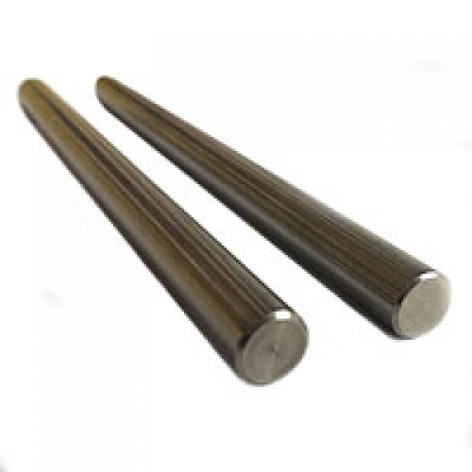

Fig.no.18.2.1

**PART NAME: SHAFT**

**MATERIAL – C30**

**QUANTITY – 1**

|  |  |  |  |
| --- | --- | --- | --- |
| Sr. No. | Operation | Machine | Time |
| 1 | Cutting the material as per our required size. | Power chopsaw | 10 min |
| 2 | facing both side | Lathe machine | 10 min |

**19. FOLLOWING OPERATIONS WERE PERFORMED TO FABRICATE THE WHEEL MOUNTING**

**19.1. Cutting:**

The material as our required size. The machine used for this operation is power chop saw. A power chop saw, also known as a drop saw, is a power tool used to make a quick, accurate crosscut in a workpiece at a selected angle. Common uses include framing operations and the cutting of molding. Most chop saws are relatively small and portable, with common blade sizes ranging from eight to twelve inches. The chop saw makes cuts by pulling a spinning circular saw blade down onto a workpiece in a short, controlled motion. The workpiece is typically held against a fence, which provides a precise cutting angle between the plane of the blade and the plane of the longest workpiece edge. In standard position, this angle is fixed at 90°. A primary distinguishing feature of the miter saw is the miter index that allows the angle of the blade to be changed relative to the fence. While most miter saws enable precise one-degree incremental changes to the miter index, many also provide "stops" that allow the miter index to be quickly set to common angles (such as 15°, 22.5°, 30°, and 45°). The time required for this operation is 50 minutes.

**19.2. Finishing:**

The edges with grinder using grinding wheel. The machine used for this operation is hand grinder. An angle grinder, also known as a side grinder or disc grinder, is a handheld power tool used for cutting, grinding and polishing. Angle grinders can be powered by an electric motor, petrol engine or compressed air. The motor drives a geared head at a right-angle on which is mounted an abrasive disc or a thinner cut-off disc, either of which can be replaced when worn. Angle grinders typically have an adjustable guard and a side-handle for two-handed operation. Certain angle grinders, depending on their speed range, can be use*d* as sanders, employing a sanding disc with a backing pad or disc. The backing system is typically made of hard plastic, phenolic resin, or medium-hard rubber depending on the amount of flexibility desired. The time required for this operation is 20 minutes.

**19.3. Welding:**

Square pipes of different lengths to make frame. The machine used for this operation is electric arc welding. Electrical arc welding is the procedure used to join two metal parts, taking advantage of the heat developed by the electric arc that forms between an electrode (metal filler) and the material to be welded. The welding arc may be powered by an alternating current generator machine (welder). This welding machine is basically a single-phase static transformer Suitable for melting RUTILE (sliding) acid electrodes. Alkaline electrodes may also be melted by alternating current if the secondary open-circuit voltage is greater than 70 V. The welding current is continuously regulated (magnetic dispersion) by turning the hand wheel on the outside of the machine, which makes it possible to select the current value, indicated on a special graded scale, with the utmost precision. To prevent the service capacities from being exceeded, all of our machines are fitted with an automatic overload protection which cuts of the power supply (intermittent use) in the event of an overload. The operator must then wait for a few minutes before returning to work. This welding machine must be used only for the purpose described in this manual. Read the entire contents of this manual before installing, using or servicing the equipment, paying special attention to the chapter on safety precautions. Contact your distributor if you do not fully understand these instructions. The time required for this operation is 150 minutes.

**19.4. Polishing:**

The welded joints with hand grinder using grinding wheel. The machine used for this operation is hand grinder. With refinement, grinding becomes polishing, either in preparing metal surfaces for subsequent buffing or in the actual preparation of a surface finish, such as a No. 4 polish in which the grit lines are clearly visible. Generally speaking, those operations which serve mainly to remove metal rapidly are considered as grinding, while those in which the emphasis is centred on attaining smoothness are classified as polishing. Grinding employs the coarser grits as a rule while most polishing operations are conducted with grits of 80 and finer. If polishing is required, start with as fine a grit as possible to reduce finishing steps. There is a wide range of grinding and polishing tools on the market and advice is available from ASSDA members to assist in particular applications. Polishing operations are conducted with the abrasive mounted either on made-up shaped wheels or belts which provide a resilient backing. The base material may be in either a smooth rolled or a previously ground condition. If the former, the starting grit size may be selected in a range of 80 to 100. If the latter, the initial grit should be one of sufficient coarseness to remove or smooth out any residual cutting lines or other surface imperfections left over from grinding. In either case, the treatment with the initial grit should be continued until a good, clean, uniform, blemish-free surface texture is obtained. The initial grit size to use on a pre-ground surface may be set at about 20 numbers finer than the last grit used in grinding, and changed, if necessary, after inspection. Upon completion of the initial stage of polishing, wheels or belts are changed to provide finer grits. Polishing speeds are generally somewhat higher than those used in grinding. A typical speed for wheel operation is 2500 metres per minute. The time required for this operation is 20 minutes.

**19.5. Drilling:**

The hole at the center according to motor size. The process used for this operation is laser cutting. Laser cutting is a technology that uses a [laser](https://en.wikipedia.org/wiki/Laser) to cut materials, and is typically used for industrial manufacturing applications, but is also starting to be used by schools, small businesses, and hobbyists. Laser cutting works by directing the output of a high-power laser most commonly through optics. The laser optics and [CNC](https://en.wikipedia.org/wiki/CNC) (computer numerical control) are used to direct the material or the laser beam generated. A typical commercial laser for cutting materials would involve a motion control system to follow a CNC or [G-code](https://en.wikipedia.org/wiki/G-code) of the pattern to be cut onto the material. The focused laser beam is directed at the material, which then either melts, burns, vaporizes away, or is blown away by a jet of gas, leaving an edge with a high-quality surface finish. Industrial laser cutters are used to cut flat-sheet material as well as structural and piping materials. The time required for this operation is 30 minutes

**PART NAME : Wheel mounting**

**MATERIAL : Mild Steel**

**QUANTITY : 1**

|  |  |  |  |
| --- | --- | --- | --- |
| **Sr. No** | **OPERATION** | **MACHINE** | **TIME** |
| 1) | Cutting the material as our required size. | Power chopksaw | 50 Minute |
| 2) | Finishing the edges with grinder using grinding wheel | Hand grinder | 20 minutes |
| 3) | Welding square pipes of different lengths to make frame | Electric arc Welding | 120 Minute |
| 4) | Finishing the welded joints with hand grinder using grinding wheel | Hand grinder | 20 minutes |
| 5) | Drilling on square pipe | Drilling | 20 minutes |

**20. FOLLOWING OPERATIONS WERE PERFORMED TO FABRICATE THE CYLINDER ATTACHMENT**

**20.1. Cutting:**

The material as our required size. The machine used for this operation is power chop saw. A power chop saw, also known as a drop saw, is a power tool used to make a quick, accurate crosscut in a workpiece at a selected angle. Common uses include framing operations and the cutting of molding. Most chop saws are relatively small and portable, with common blade sizes ranging from eight to twelve inches. The chop saw makes cuts by pulling a spinning circular saw blade down onto a workpiece in a short, controlled motion. The workpiece is typically held against a fence, which provides a precise cutting angle between the plane of the blade and the plane of the longest workpiece edge. In standard position, this angle is fixed at 90°. A primary distinguishing feature of the miter saw is the miter index that allows the angle of the blade to be changed relative to the fence. While most miter saws enable precise one-degree incremental changes to the miter index, many also provide "stops" that allow the miter index to be quickly set to common angles (such as 15°, 22.5°, 30°, and 45°). The time required for this operation is 50 minutes.

**20.2. Finishing:**

The edges with grinder using grinding wheel. The machine used for this operation is hand grinder. An angle grinder, also known as a side grinder or disc grinder, is a handheld power tool used for cutting, grinding and polishing. Angle grinders can be powered by an electric motor, petrol engine or compressed air. The motor drives a geared head at a right-angle on which is mounted an abrasive disc or a thinner cut-off disc, either of which can be replaced when worn. Angle grinders typically have an adjustable guard and a side-handle for two-handed operation. Certain angle grinders, depending on their speed range, can be use*d* as sanders, employing a sanding disc with a backing pad or disc. The backing system is typically made of hard plastic, phenolic resin, or medium-hard rubber depending on the amount of flexibility desired. The time required for this operation is 20 minutes.

**20.3 Welding:**

Square pipes of different lengths to make frame. The machine used for this operation is electric arc welding. Electrical arc welding is the procedure used to join two metal parts, taking advantage of the heat developed by the electric arc that forms between an electrode (metal filler) and the material to be welded. The welding arc may be powered by an alternating current generator machine (welder). This welding machine is basically a single-phase static transformer Suitable for melting RUTILE (sliding) acid electrodes. Alkaline electrodes may also be melted by alternating current if the secondary open-circuit voltage is greater than 70 V. The welding current is continuously regulated (magnetic dispersion) by turning the hand wheel on the outside of the machine, which makes it possible to select the current value, indicated on a special graded scale, with the utmost precision. To prevent the service capacities from being exceeded, all of our machines are fitted with an automatic overload protection which cuts of the power supply (intermittent use) in the event of an overload. The operator must then wait for a few minutes before returning to work. This welding machine must be used only for the purpose described in this manual. Read the entire contents of this manual before installing, using or servicing the equipment, paying special attention to the chapter on safety precautions. Contact your distributor if you do not fully understand these instructions. The time required for this operation is 150 minutes.

**20.4. Polishing:**

The welded joints with hand grinder using grinding wheel. The machine used for this operation is hand grinder. With refinement, grinding becomes polishing, either in preparing metal surfaces for subsequent buffing or in the actual preparation of a surface finish, such as a No. 4 polish in which the grit lines are clearly visible. Generally speaking, those operations which serve mainly to remove metal rapidly are considered as grinding, while those in which the emphasis is centred on attaining smoothness are classified as polishing. Grinding employs the coarser grits as a rule while most polishing operations are conducted with grits of 80 and finer. If polishing is required, start with as fine a grit as possible to reduce finishing steps. There is a wide range of grinding and polishing tools on the market and advice is available from ASSDA members to assist in particular applications. Polishing operations are conducted with the abrasive mounted either on made-up shaped wheels or belts which provide a resilient backing. The base material may be in either a smooth rolled or a previously ground condition. If the former, the starting grit size may be selected in a range of 80 to 100. If the latter, the initial grit should be one of sufficient coarseness to remove or smooth out any residual cutting lines or other surface imperfections left over from grinding. In either case, the treatment with the initial grit should be continued until a good, clean, uniform, blemish-free surface texture is obtained. The initial grit size to use on a pre-ground surface may be set at about 20 numbers finer than the last grit used in grinding, and changed, if necessary, after inspection. Upon completion of the initial stage of polishing, wheels or belts are changed to provide finer grits. Polishing speeds are generally somewhat higher than those used in grinding. A typical speed for wheel operation is 2500 metres per minute. The time required for this operation is 20 minutes.

**20.5. Drilling:**

The hole at the center according to motor size. The process used for this operation is laser cutting. Laser cutting is a technology that uses a [laser](https://en.wikipedia.org/wiki/Laser) to cut materials, and is typically used for industrial manufacturing applications, but is also starting to be used by schools, small businesses, and hobbyists. Laser cutting works by directing the output of a high-power laser most commonly through optics. The laser optics and [CNC](https://en.wikipedia.org/wiki/CNC) (computer numerical control) are used to direct the material or the laser beam generated. A typical commercial laser for cutting materials would involve a motion control system to follow a CNC or [G-code](https://en.wikipedia.org/wiki/G-code) of the pattern to be cut onto the material. The focused laser beam is directed at the material, which then either melts, burns, vaporizes away, or is blown away by a jet of gas, leaving an edge with a high-quality surface finish. Industrial laser cutters are used to cut flat-sheet material as well as structural and piping materials. The time required for this operation is 30 minutes

**PART NAME : Attachment for connection of cylinder to brake drum**

**MATERIAL : Mild Steel**

**QUANTITY : 1**

|  |  |  |  |
| --- | --- | --- | --- |
| **Sr. Number** | **OPERATION** | **MACHINE** | **TIME** |
| 1) | Cutting the material as our required size. | Hand grinder | 20 Minutes |
| 2) | Finishing the edges with grinder using grinding wheel | Hand grinder | 20 minutes |
| 3) | Welding square pipes of different lengths to make frame | Electric arc Welding | 120 Minute |
| 4) | Drilling holes to mount cylinder | Drilling machine | 10 minutes |

**PART NAME : bearing holders**

**MATERIAL : Mild Steel**

**QUANTITY :**

|  |  |  |  |
| --- | --- | --- | --- |
| **Sr. Number** | **OPERATION** | **MACHINE** | **TIME** |
| 1) | Cutting the material in circular shape as per required outer diameter | Laser cuttting | 20 Minutes |
| 2) | Drilling hole at the centre according to required bearing size | Laser cutting | 20 minutes |
| 3) | Fitting the bearing inside the holder | Press machine | 10 minutes |

**21. ADVANTAGES**

1. Easy construction.

2. It provide safety of driver and vehicle.

3. It reduce accident intensity.

4. This system improve the response time of vehicle braking to keep safe distance between two vehicles.

**22. DISADVANTAGES**

1. Cost is high because of use of compressor.

2.IR sensor range is small.

3. Only useful for front side protection.

4.Not useful when vehicle will be come at back side.

**23. CONCLUSION**

Behind the designing of this system, our main aim is to improve the prevention technique of accidents and also reducing the hazard from accidents like damage of vehicle, injury of humans, etc. We observed that our work is able to achieve all the objectives which are necessary.

Initial cost of cars with air bags is always high. Usually air bags are given to high end cars. By implementing this project we can reduce cost of high end cars by giving similar kind of safety. Air bags are helpful to provide internal safety to people sitting in vehicle, whereas in our project we will be giving internal plus external safety to car from damage.

Thus we will reduce initial cost of cars and also provide better safety.

**23.1. Future scope**

1. Infrared sensors can be replaced by ultrasonic sensors.
2. Pneumatic bumpers can be replaced by external air bags.
3. Infrared sensors can sense eye blinking and give signal to solenoid valve when driver sleeps.

**24. REFERENCES**

1. srinivasa chari.v, dr.venkatesh p.r, dr.prasanna rao n.s, adil ahmed s “automatic pneumatic bumper and break actuation before collision”, 2015, international research journal of engineering and technology (irjet) volume: 02 issue: 04, pp1015-1023
2. dr. p. poongodi. mr. p. dineshkumar, “automatic safety system for automobiles”
3. dr.eung soo kim,”fabrication of auto braking system using sensor”, international journal of control and automation, vol-2, and no1.
4. takahiro wada, “a deceleration control method of automobile for collision avoidance based on driver perceptual risk”

ieee international conference on intelligent robots and systems, oct 4881-4886.

1. lee,“a theory of visual control of braking based on information about time to collision”, perception, vol 5, pp 437-459
2. j. t. wang, “an extendable and retractable bumper”
3. jadhav n. d., gulmire s.m., ghutukade r.s., gaikwad a.s., prof.fegade s.g. “automatic braking with pneumatic bumper system” 2015,ijsart volume 1 issue 5,pp
4. katore s.r., kadlag s.c., mane p.v., pawar g.v., prof.londhe b.c., “automatic braking with pneumatic bumper system”, 2015, international journal of engineering, education and technology (ijeet), volume 3, issue 2
5. erik coelingh, lottajakobsson, henrik lind, magdalena lindman, “collision warning with auto brake - a real-life safety perspective”, volvo car corporation sweden paper number 07-0450